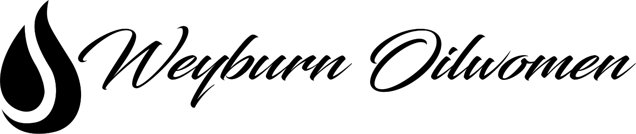
DONATION and SPONSORSHIP APPLICATION
Application Eligibility:
- Must apply formally using form
- Your event is at least six weeks from application date
- Your request is for fundraising purposes only
The Weyburn Oilwomen Association Inc. has been built by a group of strong, determined women and we believe that empowering women and our community can lead to amazing things. We want to be sure that the organizations and causes we align ourselves with support our beliefs and views. Therefore, priority will be given to those organizations and/or events that directly support females.
Application Requirements:
- Completed Application Form
- Letter head from your organization to support or provide more information of request
- Any additional information such as quotes, pictures, references
Processing Your Request:
Completed request forms can be emailed to weyburnoilwomen@gmail.com. Requests will not be accepted in any other format. Once your request has been submitted, you will receive an email back confirming the receipt of your request. The email address that the form was received from will be used for any future communication for this request unless a different contact is stated below. After your request has been reviewed, you will receive an email notification as to whether or not your request has been approved. The Weyburn Oilwomen Association Inc. will make every effort to process your request within 30 days of receiving your request. We will strive to ensure donations are sent out 2 weeks in advance of specified required date. Please keep in mind that submitting a request does not guarantee that you will receive a donation as resources are limited. All decisions made by the Weyburn Oilwomen Association Inc. are final. We wish you all the best with your events and initiatives and thank you for doing your part to make the world a better place.
Approved Application Requirements:
Upon approval of your application, we kindly ask for the following in return:
- Confirmation of event and outcome
- Pictures, information, documents from your event that we can share with our followers
- Recognition for our contribution – we love social media!

__

